## House-Price- Prediction Using Machine Learning

**Introduction :**

The "House Price Prediction Using Machine Learning" project aims to harness the power of data science and machine learning to create a model that can estimate house prices based on various features.

Whether you're a prospective homebuyer looking for a fair deal, a seller trying to determine the optimal listing price, or an investor seeking profitable opportunities, this project will equip you with the knowledge and tools to make informed decisions.

**INNOVATION :**

**Data Collection:**

Data collection is the process of collecting and analyzing information on relevant variables in a predetermined, methodical way so that one can respond to specific research questions, test hypotheses, and assess results. Data collection can be either qualitative or quantitative.

Example: A company collects customer feedback through online surveys and social media monitoring to improve their products and services.



**Data Preprocessing :**

Data preprocessing is the process of transforming raw data into an understandable format. It is also an important step in data mining as we cannot work with raw data. The quality of the data should be checked before applying machine learning or data mining algorithms.

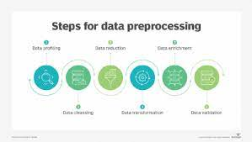

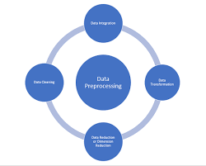

**Feature Engineering :**

Feature engineering is the process of selecting, manipulating, and transforming raw data into features that can be used in supervised learning.

In order to make machine learning work well on new tasks, it might be necessary to design and train better features.

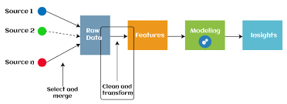

**Model Selection:**

Choosing and training appropriate machine learning models for regression, such as Linear Regression, Decision Trees, or ensemble methods like Random Forest.

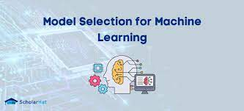

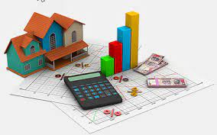

By the end of this project, you will have gained valuable insights into the world of machine learning and developed a practical solution for house price prediction, which you can use for your own real estate-related endeavors.